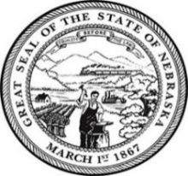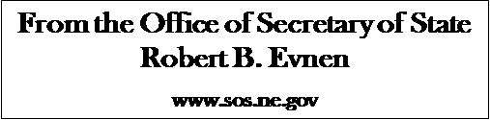
For Release:
May 5, 2020
Contact:
Cindi Allen
402-471-8408

REALTORS® stepping up in Communities to Help

LINCOLN- In times like these many Nebraskans are ready to help. Secretary of State Bob Evnen continues to recruit poll workers to take the place of our poll workers who are in a higher risk age group. Nebraska REALTORS® Association asked – how can we help? “I am grateful for our community minded Relators who desire to fill the role of poll workers in our upcoming primary election May 12,” stated Secretary Bob Evnen.
“We as REALTORS® are spending much of our time becoming familiar with and highlighting the attributes of our local areas. REALTORS® are advocates across Nebraska. And we are dedicated community volunteers who give back. So, in the spirit of demonstrating civic duty I encourage REALTORS® to participate”, says Nebraska REALTORS® Association President Steve Coram, from Kearney, NE.
Every polling site will receive kits that includes:
• At least 2 N95 masks per poll worker
• 25 pairs of gloves
• 540 ml bottle of hand sanitizer
• A canister of disinfecting wipes
- Individual black pens for each voter to keep
- Social distancing standards will apply.
- Mask available for voters who need them

You can also help by sharing the opportunity with family, friends, neighbors, colleagues and anyone else who may be an ideal fit. Contact your local county office by phone or email if you wish to serve as a poll worker.

Make a difference in your community and become a proud poll worker. For county election contact information visit https://sos.nebraska.gov/elections/election-officials-contact-information
###

